**Employees submitting for overtime**

1. An employee can only submit for overtime between 2-14 days of when the overtime will take place.
2. An employee can only withdraw their name from overtime between 2-14 days of when the overtime will take place.

**Employee Eligibility**

Two days before a block of overtime will take place the employee’s ability to submit/withdraw from the overtime will be locked and the most eligible employee will be awarded the overtime.

For an employee to be considered most eligible they will be tested on the following parameters in this order:

1. Has signed up to work the overtime block
2. Is on the off-going shift
3. Has the least opportunity overtime hours
4. Has seniority in the job
5. The oldest submission date

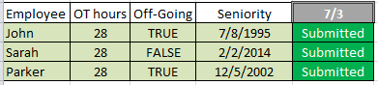

On 7/1 the submission/withdrawal for overtime blocks on 7/3 are locked.

The decision process of who will be awarded the overtime of 7/3 works like the following:

1. Who wants to work the overtime? **John, Sarah, and Parker**
2. Out of these names, who is on the Off-going shift? **John and Parker**
3. Out of these names, who has the least overtime hours? **John and Parker**
4. Out of these names, who has seniority? **John**

John is awarded the overtime and now has 36 OT hours.

**Opportunity overtime hours**

When an employee does not submit for an overtime block that they would have been awarded they are also charged with the overtime hours as opportunity overtime hours.

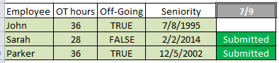

On 7/7 the submission/withdrawal for overtime blocks on 7/9 are locked.

The decision process of who will be awarded the overtime of 7/9 works like the following:

1. Who wants to work the overtime? **Sarah and Parker**
2. Out of these names, who is on the Off-going shift? **Parker**
3. Out of these names, who has the least overtime hours? **Parker**
4. Out of these names, who has seniority? **Parker**

Parker is awarded the overtime and now has 44 OT hours.

If John would have submitted his name he would have been more eligible than Parker because he has Seniority. Because of this opportunity John’s OT hours also go up to 44.

*If Parker would have removed his name before 7/7 Sarah would have been awarded the overtime and both John and Parker’s OT hours would have still been increased.*

**Removing overtime needs**

A supervisor can remove an overtime need at any point.

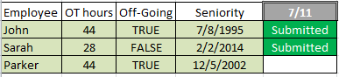

On 7/9 the submission/withdrawal for overtime blocks on 7/11 are locked.

The decision process of who will be awarded the overtime of 7/11 works like the following:

1. Who wants to work the overtime? **John and Sarah**
2. Out of these names, who is on the Off-going shift? **John**
3. Out of these names, who has the least overtime hours? **John**
4. Out of these names, who has seniority? **John**

John is awarded the overtime and now has 52 OT hours.

On 7/11 before the overtime starts the supervisor decides that it is no longer needed and removes it. John’s overtime slot is no longer workable and John is refunded the 8 OT hours returning him to 44.

**Will we need to contact an employee when their overtime slot has been canceled?**

**Multiple overtime jobs**

An employee can submit their names to be considered for multiple overtime blocks.

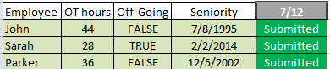

On 7/10 the submission/withdrawal for overtime blocks on 7/12 are locked.

The decision process of who will be awarded the overtime of 7/12 works like the following:

1. Who wants to work the overtime? **John, Sarah, and Parker**
2. Out of these names, who is on the Off-going shift? **Sarah**
3. Out of these names, who has the least overtime hours? **Sarah**
4. Out of these names, who has seniority? **Sarah**

Sarah is awarded the overtime and now has 36 OT hours.

On 7/12 there are 2 other overtime needs that need to be filled. The above process will run again but without Sarah’s name in the submissions.

The second time Parker is awarded the overtime and now has 44 OT hours. Parker’s name is removed from the submissions.

The third time John is awarded the overtime hours and now has 52 OT hours.

Their names will also be pulled from other overtime blocks that would conflict with their new schedule.

Any overtime hours accumulated during this process will be used to determine their eligibility for other overtime needs.

**Supervisors finding employees for unknown vacancies**

Unknown vacancies are when an employee has called-off of work for medical/other reasons close to when their shift starts. When an unknown vacancy becomes available a list of the most eligible employees will be generated for the supervisor.

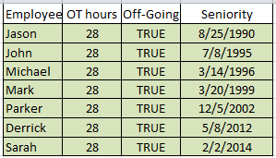

The list will be ordered by most eligible for the overtime job. For an employee to be considered most eligible in this situation they will be tested on the following parameters in this order:

1. Is on the off-going shift
2. Has the least opportunity overtime hours
3. Has seniority in the job

The supervisor will now approach each employee on the list beginning with the most eligible and offer them the overtime job. If the employee refuses the offer the supervisor will mark it as a refusal and then move on to the next employee.

If the supervisor makes it through the whole list without finding an employee, another list of the most eligible oncoming shift employees will be generated. Next to each employee will be their phone number. The supervisor can call them and continue to move through the list.

**Forced Overtime**

An employee can be forced to work an overtime slot up to 4 hours if no employee could be found to work it.

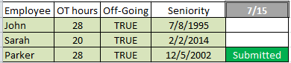

On 7/13 the submission/withdrawal for overtime blocks on 7/15 are locked.

The decision process of who will be awarded the overtime of 7/15 works like the following:

1. Who wants to work the overtime? **Parker**
2. Out of these names, who is on the Off-going shift? **Parker**
3. Out of these names, who has the least overtime hours? **Parker**
4. Out of these names, who has seniority? **Parker**

Parker is awarded the overtime and now has 36 OT hours.

On 7/15 the supervisor has a call-off that needs to be filled. He follows the procedure from page 5 and no one is willing to work the overtime.

*Sarah has now “refused” to work the known overtime that she could have submitted her name for as well as the unknown overtime the supervisor asked her to work on the 15th. This does not mean that she will be charged another 8 hours of OT. She has already been charged with the OT for this shift therefore she cannot accumulate more.*

The supervisor now needs to force the most eligible employee to work the overtime. A list is generated of the most eligible employees for the first 4 then the last 4. For an employee to be considered most eligible in this situation they will be tested on the following parameters in this order:

1. Who is on the Off-going shift? **John, Sarah, and Parker**
2. Out of these names, who hasn’t already been forced? **John and Sarah**
3. Out of these names, who has least seniority? **Sarah**

Sarah’s name is at the top of the list and must be approached and forced to work the overtime. If she refuses to work the overtime she will lose one of her 6 refusals and the supervisor will move on to the next employee on the list.

If necessary, the process is then repeated with oncoming employees to see who should work the last 4.

***Refusing Forced Overtime***

An employee can refuse to work forced overtime up to six times in a calendar year.

After 12 months from the time the refusal was made they will get the refusal back.

They can also earn a refusal if they are mandated to work overtime more than 6 times.

This earned refusal cannot be used within 10 days of it being granted and must be used within 12 months of when it was granted.

**Working hour limits**

An employee can only work a maximum of 16 hours within a 24 hour period.

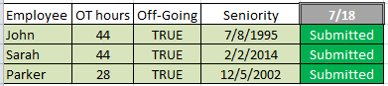

On 7/16 the submission/withdrawal for overtime blocks on 7/18 are locked.

The decision process of who will be awarded the overtime of 7/18 works like the following:

1. Who wants to work the overtime? **John, Parker, and Sarah**
2. Out of these names, who is on the Off-going shift? **John, Parker, and Sarah**
3. Out of these names, who has the least overtime hours? **Parker**
4. Out of these names, who has seniority? **Parker**

Parker is awarded the overtime and now has 36 OT hours.

The shift right after this one also needs overtime for the same job code. All three employees also applied for this one.

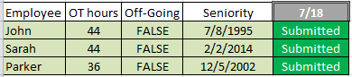

Parker would not actually show up in this list anymore because he is already scheduled to work 16 hours within 24 hours.

John would get the overtime for this shift because of his seniority.

**Submitting for First 4 or Last 4 OT Blocks**

Employees who submit for the full 8 hours of overtime are automatically more eligible than employees who submit for only the first/last 4.

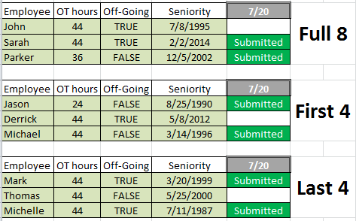

For this scenario there are 3 overtime slots available for this job code and shift number. The decision process always starts with the employees who are willing to work the full 8. If there are any slots left it will split them and start filling with the other 2 OT blocks employees have submitted.

On 7/18 the submission/withdrawal for overtime blocks on 7/20 are locked.

The decision process of who will be awarded the overtime of 7/20 works like the following:

1. Who wants to work the overtime? **Sarah and Parker**
2. Out of these names, who is on the Off-going shift? **Sarah**
3. Out of these names, who has the least overtime hours? **Sarah**
4. Out of these names, who has seniority? **Sarah**

Sarah is awarded the first overtime slot. Parker will be awarded the second as he is the only other employee who is willing to work the full 8. The remaining overtime slot will be split and then filled by the first/last 4 OT blocks. The first 4 OT block will be awarded to Jason and the last 4 OT block will be awarded to Michelle.

A supervisor can generate an OT need that is only for the first/last 4. At which point the need will be filled by the corresponding OT block submissions.

An employee can still submit for all three OT blocks but the full 8 will be prioritized.

**Employees coming into and exiting from job codes regarding Overtime Opportunity**

When employees transfer or start into a new job code or shift code their overtime opportunity hours will be set to the highest number of hours of anyone in that specific job or shift. In the case of an employee moving out of a job code or shift and then moving back this same rule applies.

**Employees in training**

Employees in training should not be considered for OT opportunity tracking.

**Current overtime system**

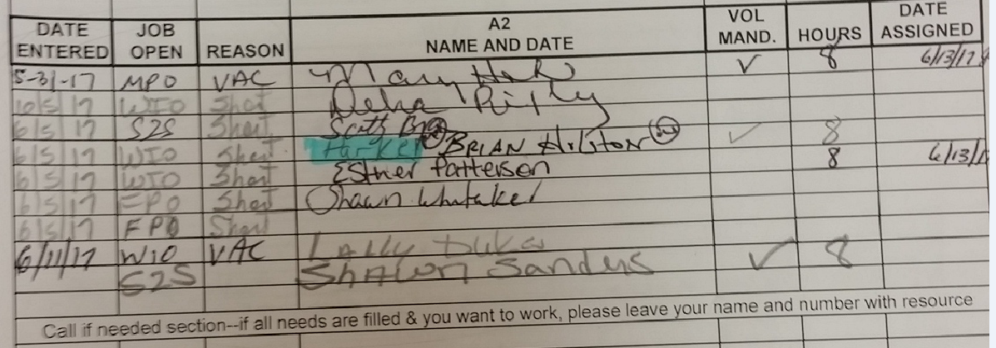

There is a book in the supervisor office with all of the overtime needs posted in it. The supervisor uses a calendar to keep track of all of the vacation time the employees have requested and will use that information to write in overtime needs. Employees then look through the book and write their names in for the overtime slots they want.

An employee can also write their names in to show that they are willing to work if any overtime becomes available. At the bottom of the list in the photo above you can see where Shawn has written his name as a volunteer, should overtime become available.

If an employee sees someone signed up for an overtime slot that they know they would be more eligible for they can ‘bump’ them and take their spot. In the photo above you can see an example of this. Brian saw that Parker was going to work an overtime slot and knew that he would be more eligible for it. Brian used a highlighter to mark out Parkers name and wrote his own name in instead.

The supervisor will review the list and date the overtime slot to show that it has been assigned to that employee. Once it has been assigned the employee is expected to work the overtime slot.